1. What is Exploratory Testing?

-> it is a type of experience based testing. It is thinking structured as compared to procedural structure of scripting testing. It is highly teachable and manageable technique.

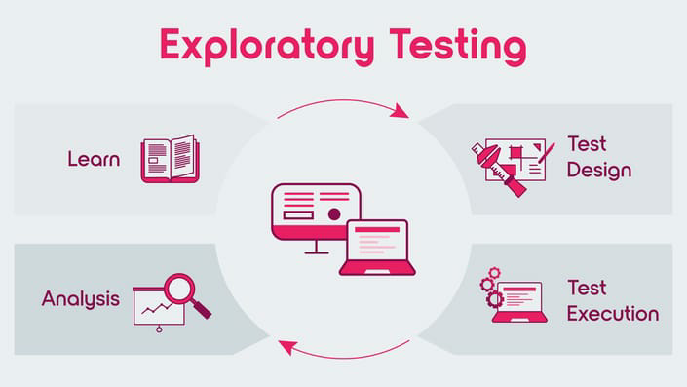

This technique is only for highly skilled and experienced tester who's know all the technical and non-technical part of the software

1. What is traceability matrix?

-> it is a type of matrix that holds all requirements, cases , other all info about the software that is necessary to be documented. This traceability matrix documents are creates the testers. There are 3 types of traceability matrix Forward, Backward,Bi-Directional traceability.

They are used to Mapping of Requirements to test cases. Mapping of Test Cases to Requirements. Good traceability matrix is the References From test cases to basis documents.

Through this we can easily identify the missing functionality.

1. What is Boundary value testing?

-> it is one of the technique of Black Box testing. It is a methodology for designing test cases that is for software testing. It is for showing the boundary limits functionality.

It means when we check the valid range of boundary in any software or anything it is called as boundary analysis.

For example when we filling the form of anything we check the text bar.

Check bar's minimum and maximum limit to accept the values it is the boundary analysis.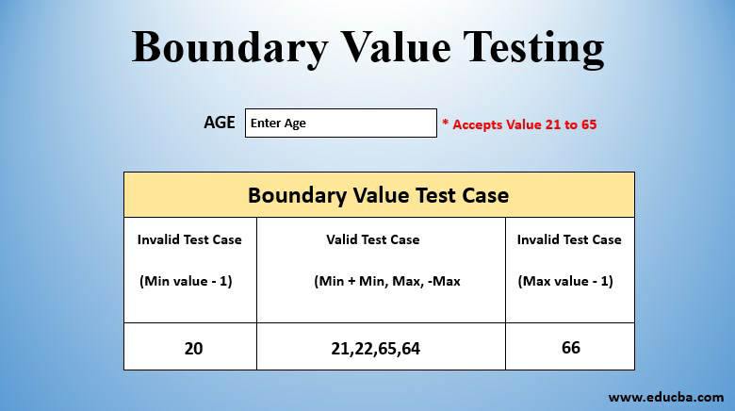

1. What is Equivalence partitioning testing?

-> it is a first type of Black Box testing technique. It is use for all levels of testing. It is the process of defining the optimum number of test.

If value>=1 AND Value<=100 Then.

In this technique there are 2 invalid partitioning and one valid partition.

It is also used to check the functionality of ending limits at both sides.

For example: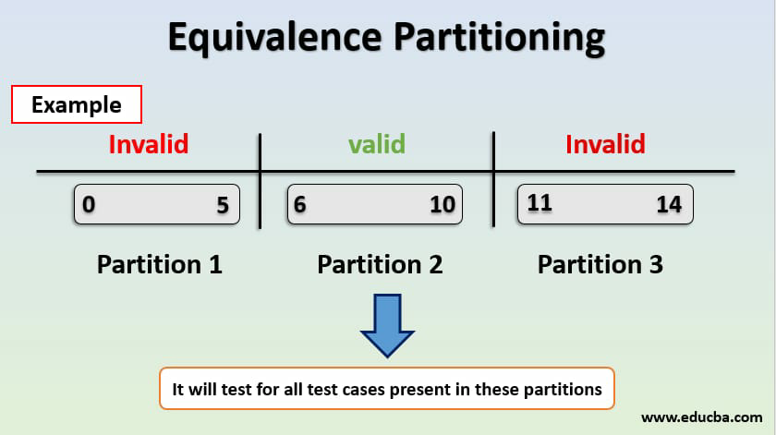

1. What is Integration testing?

-> Integration testing is a type of software testing that checks how different modules or components of a system work together as a whole. It is done to ensure that the individual parts of a system are working correctly when they are integrated with each other. The purpose of integration testing is to detect any defects or errors that may arise from the interaction between different components of a system. 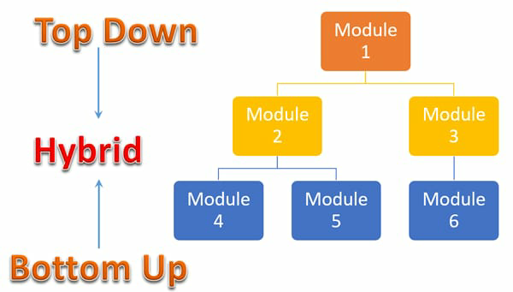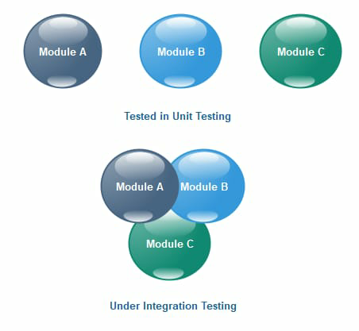

It is a 2nd stage of Testing Levels

1. What determines the level of risk?

-> The level of risk in software testing is determined by several factors including the complexity and criticality of the system, the skill and experience of the testers, availability of resources, time constraints, changes in requirements, dependencies on other systems, and regulatory compliance requirements.

1. What is Alpha Testing ?

-> Alpha testing is a type of software testing that is conducted by the development team or a group of testers before the software is released to the public. It is usually done in-house and involves testing the software in a simulated environment to identify any bugs, defects, or usability issues. The purpose of alpha testing is to ensure that the software meets the requirements and specifications and to fix any issues before it is released to beta testing and ultimately to the public.

1. What is Beta Testing ?

-> Beta testing is a type of software testing that is conducted by a group of external users or customers before the software is released to the public. It is usually done after alpha testing and involves testing the software in a real-world environment to identify any bugs, defects, or usability issues that were not found during alpha testing. The purpose of beta testing is to get feedback from real users and to ensure that the software is ready for release to the public. Beta testers may be asked to provide feedback on the user interface, performance, functionality, and overall user experience.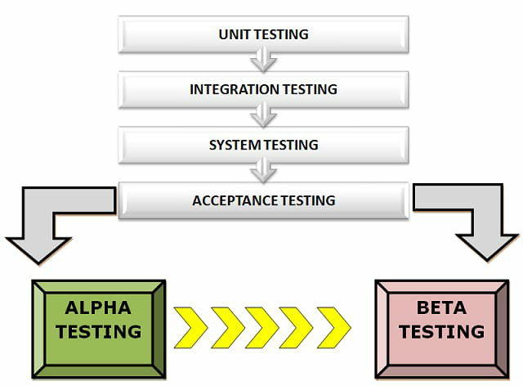

1. What is component testing ?

-> Component testing is a type of software testing that focuses on testing individual components or modules of a software system in isolation. It is also known as unit testing and involves testing each component or module separately to ensure that it works as expected and meets the specified requirements. Component testing is usually done by developers during the development phase and involves testing the code, interfaces, and interactions between different modules. The purpose of component testing is to identify any defects or errors in the individual components before they are integrated into the larger system. This helps to ensure that the overall system functions correctly and reduces the risk of bugs or defects in the final product.

1. What is functional system testing

-> Functional system testing is a type of software testing that focuses on testing the entire system or application as a whole to ensure that it meets the specified functional requirements. It involves testing the system's behavior and functionality under different scenarios and inputs to verify that it performs as expected. Functional system testing is usually performed after integration testing and involves testing the system's user interface, database, APIs, and other components to ensure that they work together seamlessly. The purpose of functional system testing is to identify any defects or errors in the system's functionality and to ensure that it meets the end-users' requirements.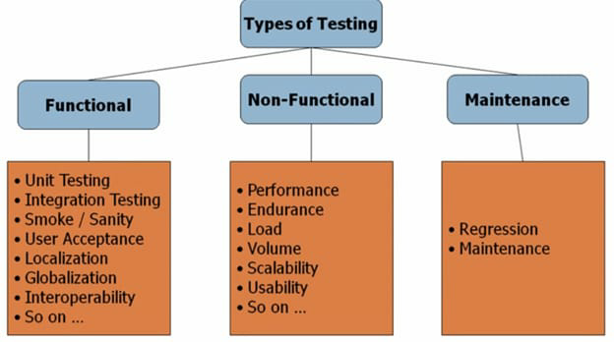

1. What is Non-Functional Testing ?

-> Non-functional testing is a type of software testing that focuses on testing the non-functional aspects of a system or application, such as performance, usability, reliability, security, and scalability. Unlike functional testing, which tests the system's behavior and functionality, non-functional testing evaluates how well the system performs under different conditions and how well it meets the non-functional requirements. Non-functional testing includes testing the system's response time, load handling capacity, security vulnerabilities, user experience, and other non-functional aspects to ensure that it meets the desired standards and specifications. The purpose of non-functional testing is to identify any potential issues or defects in the system's non-functional aspects and to ensure that it provides a satisfactory user experience.

1. What is GUI Testing?

-> GUI testing, or Graphical User Interface testing, is a type of software testing that focuses on evaluating the graphical user interface of a system or application. GUI testing involves testing the visual elements, such as buttons, menus, icons, and images, to ensure that they are displayed correctly and function as intended. GUI testing also includes testing the user interactions with the system, such as mouse clicks, keyboard inputs, and touch screen gestures, to ensure that they are processed correctly and produce the expected results. The purpose of GUI testing is to ensure that the system's user interface is easy to use, intuitive, and meets the user's requirements and expectations. GUI testing is an essential part of software testing, as the user interface is the primary means of interaction between the user and the system.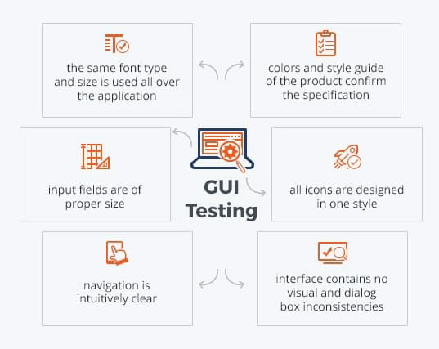

1. What is Adhoc testing ?

-> Adhoc testing is an informal and unstructured software testing technique that is performed without any predefined test cases or test plans. It is a type of exploratory testing that is conducted by the tester based on their intuition, experience, and knowledge of the system under test. Adhoc testing involves randomly selecting and executing test cases to uncover defects or issues that may have been missed during formal testing. Adhoc testing can be performed at any stage of the software development life cycle and can be used to supplement other types of testing such as functional testing, regression testing, and performance testing. The primary goal of adhoc testing is to identify defects and improve the overall quality of the software product.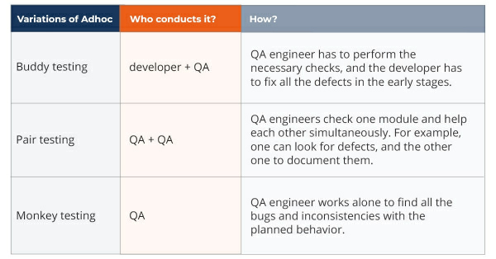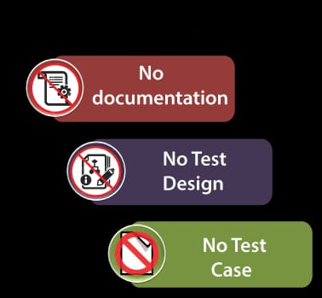

1. What is load testing ?

-> Load testing is a type of software testing that is conducted to determine how a system performs under a specific workload. It involves simulating a high volume of users or transactions to evaluate the system's response time, throughput, and resource utilization. The purpose of load testing is to identify performance bottlenecks and ensure that the system can handle the expected user load without crashing or slowing down. 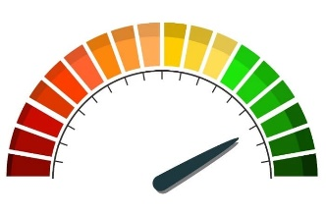Load testing can be conducted using various tools and techniques, including stress testing, endurance testing, and spike testing. It is typically performed during the later stages of the software development life cycle to ensure that the system can handle the

expected user load in production.

1. What is stress Testing?

-> stress Testing is type of non functional testing. Stress testing is a type of software testing that evaluates the performance of a system or application under extreme conditions. It involves subjecting the system to a heavy load or high traffic volume to see how it responds and whether it can handle the stress without crashing or slowing down. The goal of stress testing is to identify any weaknesses or bottlenecks in the system and determine its maximum capacity. This type of testing is especially important for applications that are critical to business operations, such as e-commerce websites or financial systems, where even a brief interruption can cause significant damage.

1. What is white box testing and list the types of white box testing ?

-> White box testing is a type of software testing that evaluates the internal structure and design of an application or system. It involves analyzing the code, architecture, and algorithms used in the software to ensure that they are functioning correctly. The goal of white box testing is to identify any errors or defects in the code that could affect the functionality or performance of the application.

Ex. Web Based Testing

Desktop Based Testing

Mobile Based Testing

Game Based Testing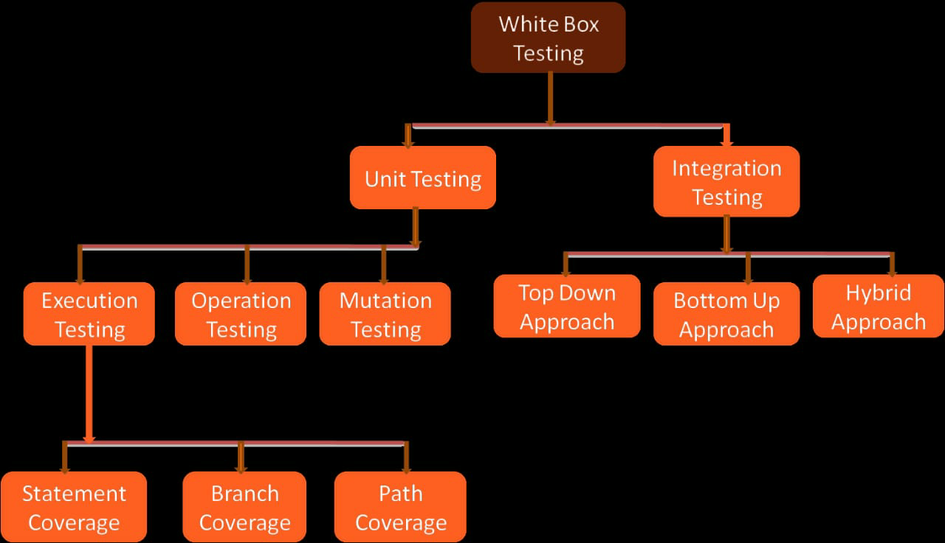

There are several types of white box testing

Unit testing: This type of testing focuses on individual components or modules of the application to ensure that they are working as intended.

Integration testing: This type of testing evaluates how different components or modules of the application work together to ensure that they are integrated correctly.

Performance testing: This type of testing evaluates how well the application performs under various conditions, such as high traffic or heavy loads.

Security testing: This type of testing evaluates the security features and protocols of the application to ensure that they are protecting against potential threats and vulnerabilities.

1. What is black box testing? What are the different black box testing techniques?

-> Black box testing is a type of software testing that evaluates the functionality of an application or system without examining its internal structure or design. It focuses on the input and output of the software, and tests it based on its specifications and requirements.

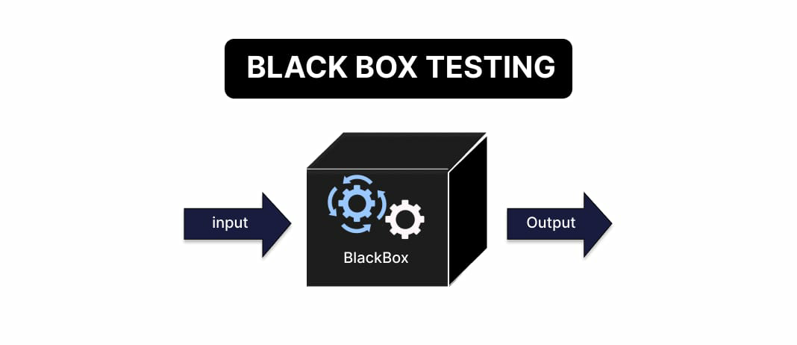

There are several types of black box testing techniques, including:

Boundary value analysis: This technique tests the input and output values at the boundaries of acceptable ranges to ensure that the software is handling them correctly.

Equivalence partitioning: This technique divides the input data into different partitions or groups to ensure that the software is handling them correctly.

Decision table testing: This technique tests the different combinations of inputs and outputs to ensure that the software is making correct decisions.

State transition testing: This technique tests the different states of the software to ensure that it is transitioning correctly between them.

1. Mention what are the categories of defects ?

Categories of defects

Data quality

Database defect

Critical functionality defect

Functionality defect

User interface defect

Security defect

1. Mention what is bigbang testing ?

-> Big bang testing is an approach in software testing where all the modules or components of an application are integrated and tested together as a single unit. This approach is usually adopted when there is a time constraint and the application is small or simple. In big bang testing, the testers do not follow any specific order of integration or testing, and all the modules are integrated simultaneously. This approach may lead to issues being missed during testing as the entire application is tested as a whole, and it becomes difficult to identify the root cause of defects.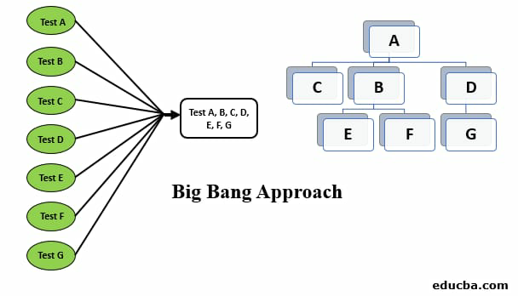

1. What is the purpose of exit criteria?

-> Exit criteria in software testing refers to the set of conditions or requirements that must be met before testing can be considered complete and the software can be released. The purpose of exit criteria is to ensure that the software meets the quality standards, functional requirements, and other specifications set by the stakeholders. It helps to ensure that the software is ready for deployment and that it will perform as expected in the production environment. Exit criteria may include factors such as the number of defects found, the level of test coverage achieved, the completion of all planned tests, and the approval of stakeholders. By defining clear exit criteria, software testing teams can ensure that they have thoroughly tested the software and that it is ready for release.

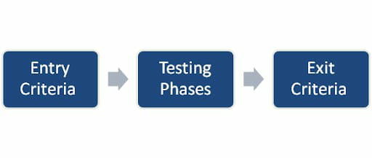

1. When should "Regression Testing" be performed?

-> Regression testing should be performed in software testing whenever there is a change made to the software, such as a bug fix, a new feature, or a code update. Regression testing is the process of retesting the software to ensure that the changes made have not introduced any new defects or caused any existing functionality to break. It is important to perform regression testing after any change to the software to ensure that it continues to meet the quality standards and functional requirements set by the stakeholders. Regression testing can be automated or performed manually, depending on the complexity of the software and the available resources.

1. What is 7 key principles ? Explain in detail.

-> These are the 7 general testing principles.

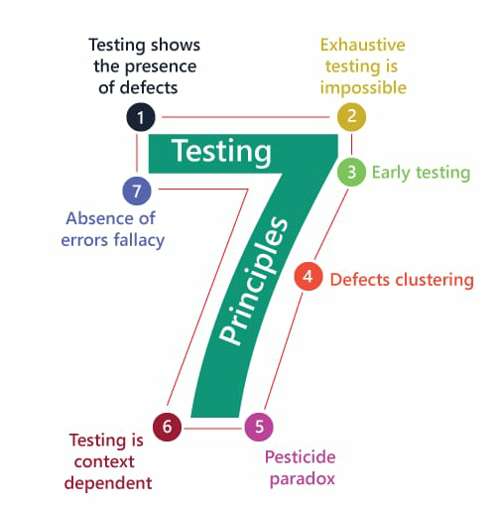

# Testing shows presence of defects Testing reduces the probability of undiscovered defects remaining in the software but, even if no defects are found, it is not a proof of correctness.

# Exhaustive testing is impossible

Testing everything including all combinations of inputs and preconditions is not possible. Priorities our testing effort using a Risk Based Approach.

# Early testing

Testing activities should start as early as possible in the development life cycle. this activities should be focused on checking of client’s requirements

# Defect clustering

A small number of modules contain most of the defects discovered during

pre-release testing or are responsible for the most operational failure

#The pesticide paradox

The test cases need to be Regularly reviewed and revised and new and different tests need to be written to exercise different parts of the software or system to potentially find more defects. As bugs are eliminated by the programmers, the software improves and the effectiveness of previous tests erodes.

#Testing is context dependent

Different kinds of sites are tested differently. example Safety

critical software is tested differently from an e-commerce sites

#Absence of errors fall If the system built is unusable and does not fulfill the user’s needs and expectations then finding and fixing defects is impractical.

23)Difference between QA/QC/Tester.

#Quality Assurance(QA)

Focus on process and procedures of actual testing on the system Process oriented activities Preventive activities

Subset of software testing life cycle (STLC)

#Quality control (QC)ol

Focus on actual testing by executing software identify bug/Defect Product oriented activities It is Corrective process Subset of Quality Assurance(QA)

#Testers

Focus on actual testing of softwares Product oriented activities

It is Preventive process

Subset of Quality Conrol(QC)

24) Difference between Smoke and Sanity?

-> Smoke testing and sanity testing are both types of software testing that are performed to ensure the stability and functionality of the software. However, there are some differences between them:

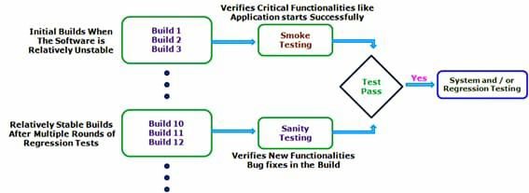

Smoke Testing:

- Smoke testing is a type of testing that is performed to ensure that the critical functionalities of the software are working properly after a build or release.

- It is a quick and shallow test that is performed to check if the software can be further tested or not.

- Smoke testing is performed before any detailed testing is done on the software.

- The main objective of smoke testing is to identify major defects or issues that may prevent further testing.

Sanity Testing:

- Sanity testing is a type of testing that is performed to ensure that the new changes or enhancements made to the software are working properly and have not adversely affected the existing functionalities.

- It is a more detailed test than smoke testing and is performed after smoke testing.

- Sanity testing is performed to ensure that the software is stable enough to undergo further testing.

- The main objective of sanity testing is to identify any major issues or defects introduced due to recent changes in the software.

Simple words smoke testing is performed to ensure that the software is stable enough to undergo further testing, while sanity testing is performed to ensure that the new changes or enhancements made to the software have not adversely affected the existing functionalities.

25)Difference between Verification and Validation

-> Verification is includes checking documents, design, codes and programs

Verification is the static testing. It comes before validation

Methods used in verification are reviews, walkthroughs, inspections and desk-checking.

It can find the bugs in the early stage of the development

Verification is for prevention of errors

Verification is about process, standard and guideline

-> Validation is includes testing and validating the actual product

Validation is the dynamic testing. It comes after verification

Methods used in validation are Black Box Testing, White Box Testing and non-functional testing.

It can only find bugs that could not be found by the verification process.

Validation is for detection of errors

Validation is about the product

26)Difference between SDLC and STLC ?

-> Software development life cycle

SDLC is mainly related to software development Life Cycle.

SDLC, more number of members developers are required for the whole process

SDLC, development team makes the plans and designs based on the requirements

helps in developing good quality software

Creation of reusable software systems is the end result of SDLC

Phases

(1) Requirement gathering

(2) Analysis phase

(3) Design phase

(4) Implementation phase

(5) Testing phase

(6) Maintenance phase

-> Software testing life cycle

STLC is mainly related to software testing.

STLC, less number of members testers are needed

STLC, testing team makes the plans and designs.

It helps in making the software defects free.

A tested software system is the end result of STLC

Phases

(1) Test planning

(2) Test case development (3) Test environment setup (4) Test execution

(5) Test cycle closure

27)Explain types of Performance testing.

Performance testing is conduct on basis of software’s parameter like Stability, Speed & Scalability max user load

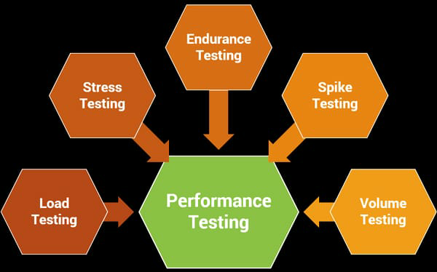

Types

(1) Load testing

(2) Stress testing

(3) Spike testing

(4) Volume testing

(5) Scalability testing

(6) Endurance testing

28) Difference between Priority and Severity.

-> Priority defines the order in which we should resolve a defect. The priority status is set based on the customer requirements.

Priority is relative & business focused

Types

Critical

High

Medium

Low

For ex.

-> It is the extent to which the defect can affect the software. In other words it defines the impact that a given defect has on the system.

Severity is absolute & customer focused

Types

Critical

Major

Moderate

Minor

Cosmetic

29)What is Bug Life Cycle?

Bug or defect life cycle is the duration or time span between the first time defect is found & the time of closed or rejected or deferred. test lead, developer, project manager, other testers

Stages of bug life cycle :

new

Assigned

Open -> duplicated rejected differed

Fixed

Pending retest

Retest ->Reopen

Verified

Closed

30) Explain the difference between Functional testing and NonFunctional testing ?

-> Functional testing and non-functional testing are two different types of software testing that are performed to ensure the quality and performance of the software. Here are the main differences between them:

Functional Testing:

- Functional testing is a type of testing that is performed to ensure that the software meets its functional requirements.

- It focuses on testing the features and functionalities of the software and making sure that they work as expected.

- Functional testing is typically performed using test cases that are designed based on the software's requirements.

- The main objective of functional testing is to ensure that the software meets the user's needs and expectations.

Non-Functional Testing:

- Non-functional testing is a type of testing that is performed to ensure that the software meets its non-functional requirements.

- It focuses on testing the performance, reliability, usability, and other non-functional aspects of the software.

- Non-functional testing is typically performed using test cases that are designed based on industry standards and best practices.

- The main objective of non-functional testing is to ensure that the software performs well under different conditions and meets the quality standards.

In summary, functional testing focuses on testing the features and functionalities of the software, while non-functional testing focuses on testing the performance, reliability, usability, and other non-functional aspects of the software. Both types of testing are important for ensuring the quality and performance of the software.

31)What is the difference between test scenarios, test cases, and test scrip.

# Test scenario

A scenario is any functionality that can be tested from use cases it Also called condition or possibility.

Scenario is give ideas in “What to be tested”

scenarios are derived from use cases

# Test case

Test cases involve the set of steps conditions and inputs which can be used while performing the testing task from test scenarios.

Testcase gives idea in “How to be tested”

Test cases are derived from test scenario

# Test Script

A set of instructions that will be perform on the system under test to test identify and system functions are as expected or not.

script is Test process specification

32) Explain what Test Plan is ? What is the information that should be covered ?

-> Test plan is a document that describing the strategy scope, approach, resources & environment schedule be intended test activities.

Factours affected test planning

Test policy, testing objectives, project risk and availability of resources, testability

Test plan Activities

Integrating and co-ordinating test activity in STLC, how result evaluate and test ware, process

Exit criteria

Related to requirement fulfill, project constraint like time and budget and number of defects remain.

33)what is priority

priority is a term that defines how ast we need to fix a defect

34)what is severity

Severity is a term that denotes how severely a defect can affect the functionality of the software

35)Bugs categories are

Categories of bugs

(1) Database bug

(2) GUI bug

(3) Functionality bug

(4) Security bug

36)Advantages of Bugzilla

Open source, free bug tracking tool.

Automatic Duplicate Bug Detection.

File/Modify Bugs By Email.

Time tracking

Move Bugs Between Installs.

Multiple Authentication Methods

LDAP

Apache server

Search option with advanced features Automated bug reporting; has an API to interact with system.Detailed permissions system Optimized database structure to enhance performance.

Robust security.

Powerful query tool

Ideal for small projects

Integrated email capabilities

37) What are the different Methodologies in Agile Development Model ?

1 Scrum

SCRUM is an agile development method which concentrates particularly on how to manage tasks within a team based development environment

2 Kanban

Kanban is a very popular framework for development in the agile software development methodology.

38)Explain the difference between Authorization and Authentication in Web testing. What are the common problems faced in Web testing?

Authentication is verifies the user Authentication works through passwords, one-time pin, biometric information, and other information provided or entered by the user. Authentication is the first step of a good identity and access management process Authentication is visible to and partially changeable by the user Authorization determines what resources a user can access

Authorization works through settings that are implemented and maintained by the organization

Authorization always takes place after authentication.Authorization isn’t visible to or changeable by the user. Problems faced in Web testing Insufficient testing for browser compatibility Fail to conduct functional testing across mobile Releasing new features breaks the existing system Bugs like crash, functional error, typos, control flow error

39) Write a Scenario of Pen Stand

-> Verify pen stand is reusable

Verify that pen stand have proper structure

Verify the different material of pen stand

Verify that for different types of pen

Verify the usability of pen stand in any weather

Verify the transportability of pen stand

Verify that it can stand on any type of surface

Verify that pen stand have different compartment

Verify that it can contain other things small size diary

40)Write a Scenario of Pen

-verify that the type of the pen. Ballpen or Gel Pen.

- verify that the user is able to hold the pen properly or not.

- verify that the pen is writing easily or not.

-verify that the material of the pen.

-verify that the ink flow of the pen.

-verify that pen is not making any kind of noise while writing.

-verify that the company name of the pen is displayed properly or not.

-verify that the company logo of the pen is displayed properly or not.

- verify that the ink color of the pen should be consistent from start to end.

-verify that the line drawn by the pen is as per specification or not. Ex. 0.5,0.6

- verify that the ink color of the pen.

-verify that the pen is able to write on different types of paper.

- verify that the ink of the pen is waterproof or not.

-verify that other refills fit in the pen or not.

- verify that the pens should not have any sharp edges or Corners.

-verify that pen is able to write at high speed.

-verify that amount of text or drawing can be done with the full refill of the pen.

-verify that the ink should not get overflowed.

- verify that the ink should not make an impression on the other side of the page.

- verify after dropping the pen from some height, the pen is working properly or not.

-verify that ink spelled or not after dropping the pen from some height.

-verify when left open for some time without a pen cap, the pen is able to write or not.

-verify that pen is able to write on a rough surface or not.

-verify that the pen is able to write on wet paper or not.

-verify without refill, the pen is working or not.

41)When to used Usability Testing?

Usability Testing identifies usability errors in the system early in development cycle and can save a product from failure. Text box, radio options, drop-down list alignment properly We use usability test when we have to check parameters like Effectiveness of the system, Efficiency, Accuracy & User Friendliness.

42)What is the procedure for GUI Testing ?

GUI testing involves checking the screens with the controls like menus, buttons, icons, and all types of bars tool bar, menu bar, dialog boxes and windows etc..

Approach

(1) Manual based testing

(2) Record and replay

(3) Model based testing

43) Write a Scenario of Door

-Verify that type of the door like a single door or bi-folded door.

-Check that type of doors like sensor door, automatic door, glass door, or manual door.

-Check the brand name of the door.

-Check the color of the door.

-Check that dimension of L*W*H of the door.

-Check the material of the door.

-Verify that lock is included or not.

-Check the thickness of the door.

-Check if the glass panel is available on the door or not.

-Check that door opens inside or outside

-Verify that door is waterproof or not.

-Verify that door’s quality is as per expected or not.

-Verify how much force is needed to open or close the door.

-Check any paintings or designs on the door.

-Verify that the stopper is available on the door not.

-Check the door have proper structure And designed

-Check the different material of door

- Check the door is open on which side inside or outside.

-Check the size of the door is as per the specification document

-Check if any levels are on the door, like push or pull

-Verify the availability of door in any colors

- Verify that door can be reusable

- Check the door is available in any size

- Verify the sustainability in any weather

- Verify door have in lock

* Verify that the door makes any sounds while opening or closing
* Verify that door is damaged or not.
* Verify that door’s condition in different seasons like rainy, winter, and summer
* Verify that door is non-scratchable or not.

- Check the door have locked in proper close and open

- Check the transportability of door

- Verify that door is fireproof, bulletproof

- Verify the automatic actions of close & open

- Check the usability of door at any surface

44). Write a Scenario of ATM

Verify the slot for insertion of ATM card.

Verify the unsuccessful operation due to insert ATM card in wrong angle.

Verify unsuccessful operation due to invalid. account Ex: other bank ATM card or time expired ATM card.

Verify the ATM screen as per specification or not.

Check the ATM machine is working properly

Verify the withdraw money action of ATM

Verify that it can work in any weather condition

Check the functionality of change pin

Check the usability of ATM with different users

check that Machine accepts card and PIN detail

check that Machine successfully take out the money

check that takes out the balance print after the withdraw

check that logs out of the client session immediately after withdraw successfully

check that generates invalid money error to money asked larger than the saving account balance

checks for the fix time in between the client sesion and wait period active in account

Verify the text visible or not in ATM screen.

Verify successful entry of PIN number.

Verify that pin is encrypted and when entered.

Verify operation due to enter wrong PIN number 3 times

Verify successful selection of language.

Verify successful selection of account type.

Verify unsuccessful operation due to invalid account type.

Verify successful selection of Withdrawal operation in Atm machine.

check that Machine does not accept card and PIN

check that Machine find wrong PIN

check that Machine find card insert in wrong way

check that Machine takes 3 invalid PIN attempt

check that Invalid account type selected in the menu

Expired card inserted in the machine

Check that it’s operating without power supply

Verify the multi user functionality at a time

Verify the ATM have fingerprint functionality

Check the authority of selection of note at withdrawal time

Check the functionality of desired money withdrawal option

Check the credit money functionality & limitations

Verify the voice command functionality of ATM

Verify successful selection of amount to be withdrawn from ATM machine.

Verify successful withdrawal operation.

Verify unsuccessful withdrawal operation due to wrong denominations in ATM machine,

Verify unsuccessful withdrawal operation due to the amount is greater than the day limit.

Verify unsuccessful withdrawal operation due to lack of money in ATM.

Verify unsuccessful withdrawal operation due to amount is greater than possible balance.

Verify unsuccessful withdrawal operation due to transactions is greater than day limit.

45) Write a Scenario of Microwave Oven

Positive

Verify that the oven’s door gets closed properly

Check that the company name is properly displayed or not

Check that the Brand logo is properly displayed on the microwave oven or not

Check that size of the microwave oven

Check that color of the microwave oven

Check that material of the microwave oven

Check that capacity of the microwave oven

Check that the compact design of the microwave oven

Check that glass is turnable or not

Check that weight of the microwave oven

Check that dimensions of the microwave oven

Check that voltage of the microwave oven

Check that batteries are required or not

Check that all buttons are properly worked or not

Check that food is properly reheating or not

Check that food is grilled properly or not

Check that the digital displayed screen should be properly visible to users

Check that oven’s door is properly opened and get closed

Check that different kinds of food at different temperature

Check that different kinds of containers

Check that temperature functionality is properly working or not

Check that the alarm sound system is properly working or not

Check that glass rotation speed is as expected

Verify that the oven’s door opens smoothly

Check that it is use properly

Check that it is constructed properly

Check the working functionality in any weather

Verify the availability of oven in any size big or small

Check that it have timer functionality

Verify the working functionality with different temperature

Check the strength of outer material of oven

Check the multiuser functionality of oven

Check oven condition when it runs for specific hours

Check that disconnecting power while cooking is in progress

Verify that it can stand on any surface

Check the working functionality without power supply

Check the modes for cooking the different items

Check the transportability of oven

Check that waterproof

Check the limit of operating temperature

46) Write a Scenario of Coffee vending machine

Check that the company logo is properly displayed or not

Check the design of the vending machine

Check that material of the vending machine

Check that dimension of the vending machine

Check that color of the coffee vending machine

Check the size of the vending machine

Check the height of the vending machine

Check that weight of the coffee vending machine

Check that labels are properly displayed on buttons or not

Verify that all the buttons should be displayed properly.

Check that it is working properly

Check the working condition in any weather

Verify the multiuser functionality

Check the availability of multi beverages option

Check the timer functionality available

Check the working condition without power supply

Check the easy transportability of machine

Verify that it have digital payment functionality

Verif that the make coffee or not

Verify that coffee vending machine should be off when the user press on power OFF button

Verify that vending machine all buttons should be working properly

Verify that when the vending machine starts, the indicator lights should be working properly.

Verify that the mechanism should be working properly when ingredients are under capacity level

Verify that the auto cleaner facility is working properly or not

Verify that the water level indicator should be working properly.

Verify that the half-cup facility is working properly or not

Verify that the cup quantity counter should work properly.

Verify that the automatic temperature is working properly or not

Verify that the safety lock system is available or not.

Verify that the cleaner should work properly for the coffee vending machine.

47) Write a Scenario of Chair

Check that the Chair has the color as per spécification or not.

Check that the arms of the Chair as per the specification or not.

Check that the seat as per the specification or not.

Check that the logo of the company is properly printed or not.

verify that length, breadth, and other size specifications of the Chair Chair as per the requirement specification or not.

Check that the Size and shape should be confirmable for Sitting or not.

verify that the material body of the Chair.

verify that the weight of the Chair.

verify that the chair’s material should not be easily damaged.

Check that cushion is provided with a chair or not.

verify that the chair’s legs are on the same level on the floor or not.

verify the height of the chair’s seat from the floor.

Check that the chair is comfortable or not.

verify that the chair is able to adjust to make height or low.

verify that the chair should be enough space to be seat.

verify that the chair is stable enough to take an average human load.

Check that there is back support

Check that chair have proper structure

Check the easy transportability of chair

Verify the different material of chair

Check the availability of chair in any size

Big or small

Check the sustainability in any weather condition

Check the multiuser functionality of chair

verify the balance of the chair with one arm.

verify the balance of the chair with three legs.

verify Chair stress testing by dropping the Chair down from the practical height.

verify that nothing is breaking, no damage to the Chair and Chair is performed without any issues.

verify that how Chair is working at different climate environmental conditions.

Check that chair have wheels or rolling functionality

Check the seat adjustment functionality of chair

Check the operate of chair by remote

Verify that it can stand on any surface

Check its sustainability against any weight

48) Scenario of Facebook Chat on Mobile

#Check the user gets all received messages in his inbox.

Check that only ‘message contacts’ will display on the left-hand side of the message box

Check the profile picture display on the left-hand side of the inbox is correct for each user

Check ‘Active’ users display with a green dot in the message box

Check unread messages are highlighted so that the user can identify it

Check received messages counts should be displayed with Inbox on the ‘Messages’ page

Check messages will get displayed in the Inbox of ‘User1’ only when ‘sender’ is connected with user1 on Facebook

Check messages will get displayed in the ‘Other’ tab of ‘User1’ if ‘sender’ is not connected with user1 on Facebook

Check the user can search contacts in the message box

Check the behavior of the chatbox if we change the network from Wi-Fi to LAN

Check the user is able to navigate to the old conversation or can view message history

Check the user is able to send a new message to a friend selected from the list present on the left-hand side

Check the message gets sent after clicking on the entering button

Check copy, and paste works in the chatbox or not

Check whether the user is able to send special characters in Chat or not.

Check that the User is able to share hyperlinked URLs, Emails, or not.

Check how many words or characters can be sent at a time.

Check that spell functionality works fine in the chatbox

Check if the user enters a message in the textbox and clicks on the refresh button without sending it

Check that the user is able to send smiley

Check that the user is able to send multiple smiles at a time

Check that if the user types smile in letters then it will look like their icon or not

Check that the User is able to share images

Check that an error message should get displayed after uploading an image of an unsupported type

Check that the User is able to share videos

Check that the User is able to share files

Check error message should get displayed after uploading large size files

Check that the user is able to send messages in local languages

Check that if the user has typed any message and navigated to another tab without sending it then the message should not get removed

Check that the user gets the appropriate message if the internet goes down while sending a message

Check that the user is able to view which device has been used to send a message.

Check that the user is able to delete the sent message

Check that the user is able to delete multiple messages at a time

Check that the user is able to view his sent messages on different devices

Check that ‘loader’ will get displayed if message sending takes time due to connection issues

Check that the User is able to send messages to other offline Users.

Check that the User is able to send messages to requests to other users who are not on the contact list

Check that the user can send direct messages to anyone from the contact list

Check by Log into Facebook more than 2 devices at a time and try to send messages>>Sent message lists and message contact list should get updated/refreshed on every device that has logged in

Check by typing a message in the chatbox and clicking on another menu>>should display a warning message to the user

Check type message in chat box>>observe how much time it remains in the chatbox (when the session will expire)

Check the blocked contacts displaying chatbox or not

Check the unfriend contacts displaying chatbox or not

Check the deleted message contacts displaying chatbox or not

#Check that download properly Facebook

Verify that open properly

Check that shows proper chat page

Check that user access the text box

Check that user can type in any languages

Verify that it support alphabets, numbers, special character

Check that it supports functionality of emoji

Verify that we can perform actions like cut, copy, paste, erase

Verify that it supports reply message functionality

Check that chat history is properly visible

Verify that it supports forward message functionality

Check that chat delete or remove functionality from both side

#Check send & receive message functionality without internet

Verify the maximum character limit of chat messages

Check its multi language functionality at a time

49). Write a Scenario of Gmail (receiving mail)

#Check that the recently received unread email is highlighted and bold in the Inbox section.

Check if all the elements of the received email are correctly displayed or not.

Check whether the user clicks on the new email; it redirects the user to the email content.

Check if the email content is displaying in the proper format or not.

Check the attached documents of the email are downloadable.

Check the already-read emails should not be the highlight.

The number of unread email counts should be displayed beside the inbox text box.

Check if the count is increased as per the number of new emails you are received.

Check the count is increased when you mark an email as unread.

Check after opening or make as read an email. The count should be decreased.

Check the names are visible to all the users whose names are present in CC & To section.

Check those names or emails are present in the BCC section and should not display to others.

Check that Gmail open properly

Check that it shows proper mail home page

Check that mail list shows with oldest and newest message

Check the scrolling functionality of mail list

Check that it shows different category of mail(primary, social,spam)

Verify that it shows sender details

Check the compatibility of receive mail functionality

Check the receiving mail functionality without internet

Check the movement functionality of mail on same page

Check that it shows option of search data from sender

50). Scenario of Online shopping to buy product (flipchart)

Check that open website propely

Check that product is available on flipkart

Check that it shows proper page of product

Check that it shows price of product properly

Check the available offers option

Check the terms & condition option of offers

Check that shows proper produt details

Check that it shows product specifications properly

Check the product image option is working properly

Check buy now option of product is working properly

Check that it shows pincode for delivery option of product

Check that on the product page, and a user can select the desired attribute of the product, e.g., size, color, etc.

Check that user can add to the cart one or more products.

Check that user can add products to the wish list.

Check that users can buy products added to the cart after signing in to the application (or as per the website’s functionality).

Check that user can successfully buy more than one products that were added to his/her cart.

Check that the limit to the number of products a user can buy is working correctly by displaying an error message and preventing the user from buying more than the threshold.

Check the availability of products at desired locations.

Check that the Cash on the Delivery option of payment is working fine.

Verify that the different pre-paid methods of payment are working fine.

Check that the product return functionality works fine.

Check that the Cancel Order option is present.

Check the buy products functionality without internet

Check that product price is available in different currecy

Check that all offers can apply at a same time

Check that it can verify multi pincode at a same time

Check the availability of delivery out of country option

Check that proper send complete order

51). Write a Scenario of Wrist Watch

Verify the wrist watch type - whether it is Analog wrist watch, Digital wrist watch or Smart wrist watch.

Verify that watch shows the correct time or not on the basis of region.

Check that user is able to set the time or change the time or not on a wrist watch.

Check that user is also able to change the day on wrist watch if it is available.

Check that all the parts of wrist watch are properly fitted or not.

Verify that the Date, Time and other information in a wristwatch is properly visible to the user not.

Verify the watch properly fit on the wrist or not.

Check the design of wrist watch as per requirement or not.

Verify if the watch is waterproof.

Verify the colour, width, dial, and length of wrist watch as per CRS or not.

Verify that the materials used for the wrist watch body are as per requirement or not.

Verify the material used for wrist watch strap -Plastic , leather .etc

Verify the wrist watch weight as per requirement or not.

Verify the Logo and name of company showing properly or not on watch.

Verify the functionality of the button of the watch working fine or not.

Check that functionality working proprly

Check the watch shows proper timing

Verify that it is wearable on wrist watch

Check that we can change time on watch

Verify the different outer material of watch

Verify the working functionality in any weather condition

Check the transportability of watch

Check that watch is waterproof

Verify the date functionality of watch

Check the working functionality without cell

Verify that it shows user temperature

Check the connectivity with other devices

Check the measure functionality like heartbeat, bp etc..

Verify the strength of core material of watch

52). Write a Scenario of Lift

Verify the Physical appearance of the lift - Dimension (Height width).

Check the metal type used in the lift - Inside and outside are as per requirement or not.

Verify the door of the lift is as per requirement or not.

Check the total capacity of the lift is as per requirement or not.

Check the total number of buttons inside the lift is as per requirement or not.

Check the total number of buttons outside of the lift is as per requirement or not.

Check the functionality of the button- Door open and close.

Check the light of the button getting on or not when the user presses it.

Check that the lift moves to the particular floor as the button of the floor is clicked.

Check that lift stops when up/down buttons on a particular floor are pressed.

Check whether the emergency button is available inside the lift or not.

Check that on click on the emergency button official getting inform or not.

Check the functionality of other buttons like - Fan, Light etc.

Verify the speed of the lift is as per requirement or not.

Verify the functionality of the lift on overload

Check the time takes to open the door after reaching on floor.

Check that when the user presses the open button before reaching the destination floor.

Check the functionality indicator of the current floor status of the lift.

Check the functionality of the voice indicator

Check how much time the lift takes to reach from one floor to another.

Check how much time the lift takes to reach from the top to the ground floor with different weights.

Check the specified weight for lift.

Check the lift functionality in an overload situation.

Check the lift functionality with no load.

Check that lift functionality properly up and down

Check that lift have proper structure

Check that lift is working properly

Verify that we can reach to place at any height

Check that it can save SStime of humans

Check functionality in critical time at hospital

Check the multiuser functionality of lift using properly

Verify that it works in any weather condition

Check that it works without power supply lift up and downs

Check the travel functionality in horizontal direction

Verify the transportability of lift

Verify that it works with different speeds in lift

Check that lift have no limits for weight

Check the operability with voice command

53). Write a Scenario of Whatsapp group

(generate group)

Check whether the user can create a new one or not.

Check the user can add multiple contacts from the contact list.

Verify the user can insert the group name and select an image for DP.

Check the user can add and remove contacts from the group.

Check that whatsapp setting and generate a new group

Check that it shows new group option

Verify the available of contact list

Check that it shows search contact option

Check that choose and add contact in new group

Check its multi selection functionality of member

Check functionality like set group name, group icon

Verify the disappearing message functionality

Check new group generate functionality without internet

Verify the maximum member add limit in new group

Verify functionality of adding unsaved member in new group

Verify that delete all data in group admin

54). Write a Scenario of instagram (video call with chat)

Check that open properly video call with chat

Check that it shows proper chat page during video call

Check that user access the text box during video call

Verify that it support alphabets, numbers, special character

Check that it supports functionality of emoji

Verify that we can perform actions like cut, copy, paste, erase

Verify that it supports reply & forward message functionality

Check that chat history is properly visible during video call

Check that it shows invite other people option on video call

Check the camera enable/disable option on video call

Check the mic enable/disable option on video call

Check the video call with chat functionality without internet

Verify the maximum character limit of chat messages

Check its multi-language functionality at a time

Check that multi people join functionality of video call

55). Write a Scenario of WhatsApp payment

verify that user is able to see Scan code screen on mobile phone or not

verify that QR code is scan from whatsapp pay

verify that user can get message for payment

Check that it shows payment option

Verify that it shows add bank account functionality

Check the availability of bank list

Check the search bank functionality in payment option

Verify that we can send money to any valid UPI id

Check that payment is securely done through UPI pin

Check payment functionality without internet

Verify the maximum transferrable limit of payment

Check the multi payment functionality at a time

Verify the availability of payment option in different currency